Intro to RMarkdown

Jake Rozran

1/9/2022

Table of Contents

# Creating a new Rmd

To lead off, there is an excellent [Rmd cheat sheet](https://raw.githubusercontent.com/rstudio/cheatsheets/main/rmarkdown.pdf) that RStudio has published. I leverage it here for examples, but I also refer to it all the time for work.

As a side note, there are many [cheat sheets](https://www.rstudio.com/resources/cheatsheets/) on the RStudio website. I encourage you to leverage these!

## Opening a new file

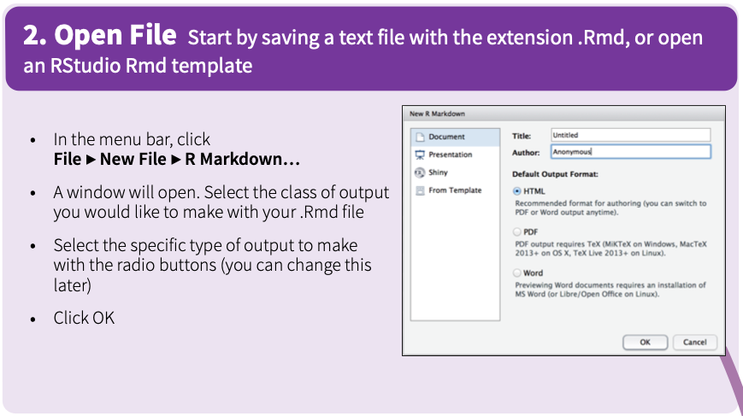

## YAML Header

This tells RStudio some basic information about the Markdown document and what to do when rendering the file (more on that below).

### This is a Basic YAML Header

---  
title: "Intro to RMarkdown"  
author: "Jake Rozran"  
date: "1/9/2022"  
output: html_document  
---

title is the title of the document.  
author is the author of the document.  
date is the date the document was created. I sometimes make this dynamic by changing this to the following (more on this below):

date: "`r Sys.Date()`"

The two other output options we *can* use in this class are word documents and pdf documents:

output: pdf_document (*Note: Requires LaTeX to be installed; not required for*  *this class.*)  
output: word_document (*Note: Will work even if Word is not installed.*)

### Adding TOC (Optional)

I like to add a table of contents to my files, especially when they are getting long.

---  
title: "Intro to RMarkdown"  
author: "Jake Rozran"  
date: "1/9/2022"  
output:   
 html_document:  
 toc: true  
 toc_float:   
 smooth_scroll: true  
 collapsed: true  
---

With floating, the TOC will “float” on the left side of the document. Otherwise, it will be at the top.

# How to Write md

Markdown is actually a language of its own - it is fairly straightforward and helps style the text of your document.

## md “Code”

Plain text   
End a line with two spaces to start a new paragraph.   
*italics* and _italics_   
**bold** and __bold__   
superscript^2^   
~~strikethrough~~   
[link](www.rstudio.com)   
`inline code`   
\```  
code chunk  
with lots of lines  
\```   
  
# Header 1  
  
## Header 2  
  
### Header 3  
  
#### Header 4  
  
##### Header 5  
  
###### Header 6  
  
endash: --   
emdash: ---   
ellipsis: ...   
inline equation: $A = \pi*r^{2}$   
  
horizontal rule (or slide break):   
  
***   
  
> block quote   
  
* unordered list  
* item 2  
 + sub-item 1  
 + sub-item 2  
  
1. ordered list  
2. item 2  
 + sub-item 1  
 + sub-item 2  
  
Table Header | Second Header  
------------- | -------------  
Table Cell | Cell 2  
Cell 3 | Cell 4

## md Rendered

Plain text  
End a line with two spaces to start a new paragraph.  
*italics* and *italics*  
**bold** and **bold**  
superscript2  
~~strikethrough~~  
[link](www.rstudio.com)  
inline code

code chunk  
with lots of lines

# Header 1

## Header 2

### Header 3

#### Header 4

##### Header 5

###### Header 6

endash: –  
emdash: —  
ellipsis: …  
inline equation: $A=π*r^{2}$

horizontal rule (or slide break):

block quote

* unordered list
* item 2
  + sub-item 1
  + sub-item 2

1. ordered list
2. item 2
   * sub-item 1
   * sub-item 2

|  |  |
| --- | --- |
| Table Header | Second Header |
| Table Cell | Cell 2 |
| Cell 3 | Cell 4 |

# The R in Rmd

The reason we use Rmd docs is so that we can run actual R code both in the markdown (inline) and in embeded code “chunks.”

## Inline R code

You can run R code in line by using a tick followed by an r and then your r code, and then finally a last tick.

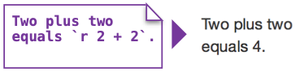

Two plus two equals 4.

## Embedded R Code Chunks

Additionally, you can create whole chunks of R code in your Rmd.

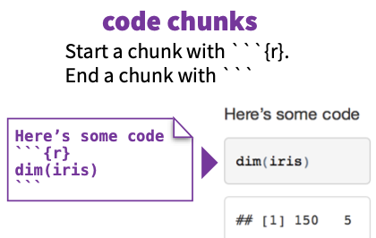

# Here we can run any R code and have it output the results  
  
4 + 4

## [1] 8

2 ^ 3

## [1] 8

"cat" %in% c("cat", "dog", "mouse")

## [1] TRUE

You can also do plots:

hist(rnorm(1000))

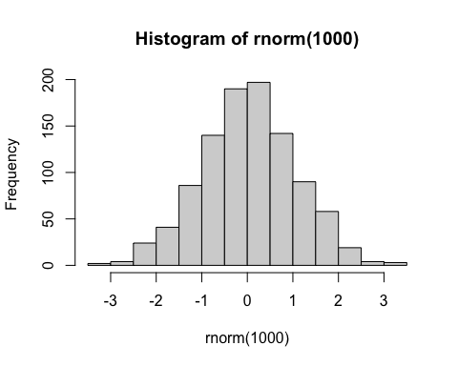

### Code Chunk Options

There are also options for each chunk that will allow you to present your results in different ways.

